Bahria University,

Karachi Campus



COURSE: Computer Fundamentals

TERM: FALL 2022, CLASS: BSE- 1 (A)

**PROJECT NAME:**

PIZZA ORDERING SYSTEM

**Group Leader:** Sarah Qasim

**Group Members:**

Mahnoor Muzaffar

Sufiyan Aasim

Submitted to

Engr. Rahemeen Khan

Signed Remarks: Score:

**TABLE OF CONTENT**

1. BACKGROUND
2. INTRODUCTION & PROBLEM
3. OBJECTIVES
4. TECHNOLOGY
5. METHODOLOGY
6. MODULE DISTRIBUTION
7. RESULT
8. CONCLUSION
9. REFERENCES

**BACKGROUND**

Computers have become part of the life for accessing almost any kind of information. In today’s age of fast food and take-out, many restaurants have chosen to focus on quick preparation and speedy delivery of orders rather than offering a rich dining experience. Until very recently, all these delivery orders were placed over the phone, but there are many disadvantages to this system, including the inconvenience of the customer needing to have a physical copy of the menu, lack of a visual confirmation that the order was placed correctly, and the necessity for the restaurant to have an employee answering the phone and taking orders. What I propose is an online pizza ordering system, which is a technique of ordering pizza online applicable in any pizza shops.

**INTRODUCTION**

Online Pizza ordering system is a web-based application that enables customers to order their pizzas online for home delivery or pick up from the pizzeria. There are a variety of food items available on this planet. Each country has its own kind of dishes to offer. But if we pick a food item which is loved by all the people on this planet, then pizza will be a clear winner in it. As the internet users are increasing exponentially, these companies have introduced an Online Pizza ordering system for taking orders from customers. This system not only improves customer’s experience but also eases the workload on the staff of pizza-licious.

**PROBLEM STATEMENT**

An online pizza ordering system enables customers to place orders online from the comfort of their location with just a click. The challenges encountered by the existing system serve as a major drawback to the realization of efficiency and customer satisfaction. The experience of ordering in food restaurants is not pleasant for the customers. Customers will have to form long queues before placing their orders, especially during peak hours. Another problem in the food service industry is that restaurants are not realizing the efficiencies that would result from better application of technology in their daily operations.

**OBJECTIVES**

The main objectives of this ordering system are:

* **Build your own pizza**

This system will help customers in ordering custom pizzas. So, the customer will pick exactly the things which he/she wants in their pizza. This will surely enhance the image of the pizza-licious and customer satisfaction will be more.

* **Online Payment**

This system will give the option to the customer for online payment. This will make the pizza buying experience cash-free.

* **Better Knowledge**

This system will provide the customer all the details of his order before making the order. This confirmation will help customers to check the items ordered with their prices.

* **Reduce Paperwork**

As most of the things will be performed online, it will reduce the usage of paper for the pizza-licious

* **Improves Efficiency**

This system will make things easier for staff as the whole ordering process is done by the customer only.

**TECHNOLOGY**

* **Web Browser**

It is an application software for accessing websites.

* **HTML**

It provides the basic structure of sites, which is enhanced and modified by other technologies like CSS and JavaScript.

* **CSS**

It is used to control presentation formatting and layout.

* **JavaScript**

It is used to control the behaviour of different elements.

* **MS Access**

It is the database management system with a graphical user interface and software development tools.

**TABLES AND RELATIONS:**

**METHODOLOGY**

Pizzalicious greatly simplifies the ordering process for both the customer and the restaurant. When the customer visits the ordering webpage, they are presented with an interactive and up-to-date menu, complete with all available options and dynamically adjusting prices based on the selected options. After selecting, the item is then added to their order, which the customer can review the details of at any time before checking out. This provides instant visual confirmation of what was selected and ensures that items in the order are, in fact, what was intended.

This system also greatly lightens the load on the restaurant’s end, as the entire process of taking orders is automated. Once an order is placed on the webpage, it is entered into the database and then retrieved, in pretty much real-time, by a desktop application on the restaurant’s end. Within this application, all items in the order are displayed, along with their corresponding options and delivery details, in a concise and easy to read manner. This allows restaurant employees to quickly go through the orders as they are placed and produce the necessary items with minimal delays and confusion.

**MODULE DISTRIBUTION**

**Item Selection:**

In this module customer can select his favourite Pizza. They can select their pizza themselves and can see the prize and current offers once he press order it will automatically add to cart items.

**My Cart:**

In this module we have all the items that user has selected all will display in order with photos and offers and finally it will also display the total price and if the change the quantity price will automatically update after seeing the price, he can buy the product.

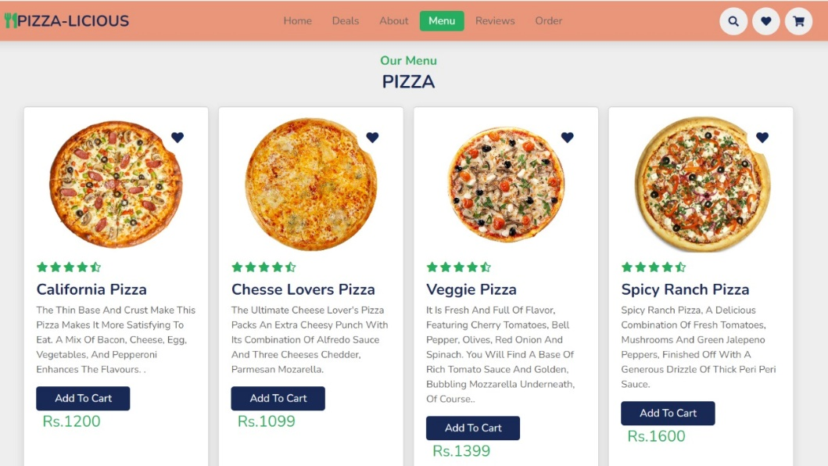

**Manage Category:**

In this module we have all the items that are on the website if we want to edit any item like if we want to change the name or if we want to change the description everything will be done in this module and finally if we want to delete also, we can delete.

**Add Reviews:**

Customers can add their responses of the service provided and rate the food quality as well as per their choices.

**RESULT**

Following are the results that one can draw from this system:

* + - People can successfully order the food using the proposed system.
    - There will be a lesser requirement of staff at the back counter.
    - The system will help in reduction of labour cost involved and reduces the space required to set up cafeterias in the restricted area.
    - As it is an automated system it is less probable to make any mistakes.
    - The customers can avoid the long queues at the counter, with a reasonable speed of execution and maximum throughput.

**CONCLUSION**

In conclusion an online food ordering system is developed for restaurants to simplify their routine managerial and operational task and to improve the dining experience of the clients. Through this, customers can make an order for the food and avoid the hassles of waiting for the order to be taken by the waiter. Using the application, the end users read the menu card and select the food from the menu card to order food online.

**REFERENCES**:

* <https://www.researchgate.net/publication/352380772_WEB_PIZZA_ORDERING_USING_PIZZA_MANAGEMENT_SYSTEM>
* <https://jpinfotech.org/online-pizza-ordering-system/>
* <https://www.studocu.com/row/document/al-furat-university/engineering/online-food-ordering-system/26659560>
* <https://www.academia.edu/35616872/ONLINE_PIZZA_ODERING_SYSTEM_PROPOSAL>
* [https://ivi.fnwi.uva.nl/fcn/teaching/2007-dbp ik/Studentprojectreport/group1.pdf](https://ivi.fnwi.uva.nl/fcn/teaching/2007-dbp%20ik/Studentprojectreport/group1.pdf)